AAC Application Requirements Document

1. Project Overview
- App Name: SpeakMyWay
- Purpose: The purpose of this application is to enable users who are neurodivergent to communicate through this AAC device. Users will be able to articulate how they are feeling, get help with transitions through activities, and learn how to form sentences. This application will be particularly important for those with disabilities like autism and are non verbal but can also be used by those looking to improve their speech.
- Platforms: iOS, Android, Web
- Optimized for Mobile Devices: The UI should be optimized for use on mobile devices like ipads, fire tablets, mobile phones and more. It should be assumed users will mostly be using on devices in which they interact by touch.
- Languages:
  - Initial Launch: English, Spanish (initial)
  - Future Roadmap: German, Mandarin Chinese, French, Dutch

2. User Types
- Free Users web app only:
  - Access speakmyway pages including Communicate, Quick Mode, and Today’s Schedule
  - Limited features in Today’s Schedule. Does not include timer, or allow for saving of routines
  - Limited Features overall: Can not save presets, limited initial vocabulary, can not create custom cards
- Premium Users:
  - Access Speak my Way on IOS or android on any device
  - Create your custom cards with uploaded images
  - User Login
  - Save Presets
  - Ability to enable ‘Sort by Most Used’ mode which will track the user’s usage and order cards in categories by how many time the user uses them.
  - Ability to customize the ‘Core’ words area
  - Timer on the Schedule Page
- Enterprise Users:
  - Same abilities on the Premium users but with enterprise access
  - Login with SSO
  - Share board preferences and created boards with those of the same enterprise
  - Can be branded with organization logo on the page

3. Core Features
List all features that will be available in the app, organized by priority:
- IOS and android app availability as well as a free version on web with some of the functionality
- Fully responsive on mobile devices like phones, tablets, computers, including kindle.
- Users can save presets for routines and things they use most often
- Ability to type freeform to be spoken by TTS
- Every time a user selects a card text to speech plays. I’d like premium voices as a future option
- A database of a large vocabulary of over 10,000 words
- Users can upload their own pictures and type words to make their own cards and add them to vocabulary.
- User log in to enable saving preferences, content like cards, and settings.
- Data tracking for the users most popular cards and the platform will sort specific card categories based on usage
- Membership tiers
- Enable log in with google and other common things
- Toggle between english and spanish to start and other languages in the future
- AI or some type of algorithm to predict next word similar to how it works on iphone when sending a text message
- Enable SSO for enterprises

Must-Have (MVP)
- Feature 1: [Brief description]
- Feature 2: [Brief description]
- ...

Should-Have (Version 1.0)
- Feature 1: [Brief description]
- Feature 2: [Brief description]
- ...

Nice-to-Have (Future Versions)
- Feature 1: [Brief description]
- Feature 2: [Brief description]
- ...

4. Page-by-Page Specifications

Home Screen
- Purpose: Home Screen is used to prompt the user to go to the other pages of the app.
- Key Elements:
  - Button to go to Communication Page: Launches Communication Page
  - Button to go to Today’s Schedule Page: Launches to Today’s Schedule Page
  - Button to Go to Quick Mode: Launches to Quick Mode Page
  - Button to Customize: Opens Customize Page
- Other Features:
  - The first time a user logs in a window should pop that says: Please enter your name. We will refer to you for the schedule and for prompts when using the application.
  - After a user enters the name the system will say: Thanks <Your Name> I’m your personal assistant, Use me to communicate. Check out our customize page to change my voice, upload your own cards, and update your profile and settings. We have help videos there as well for getting started.
- Screenshots/Mockups: This is how the page looks now using JS but I’m open to ideas and having it be even more modern and sleek looking:
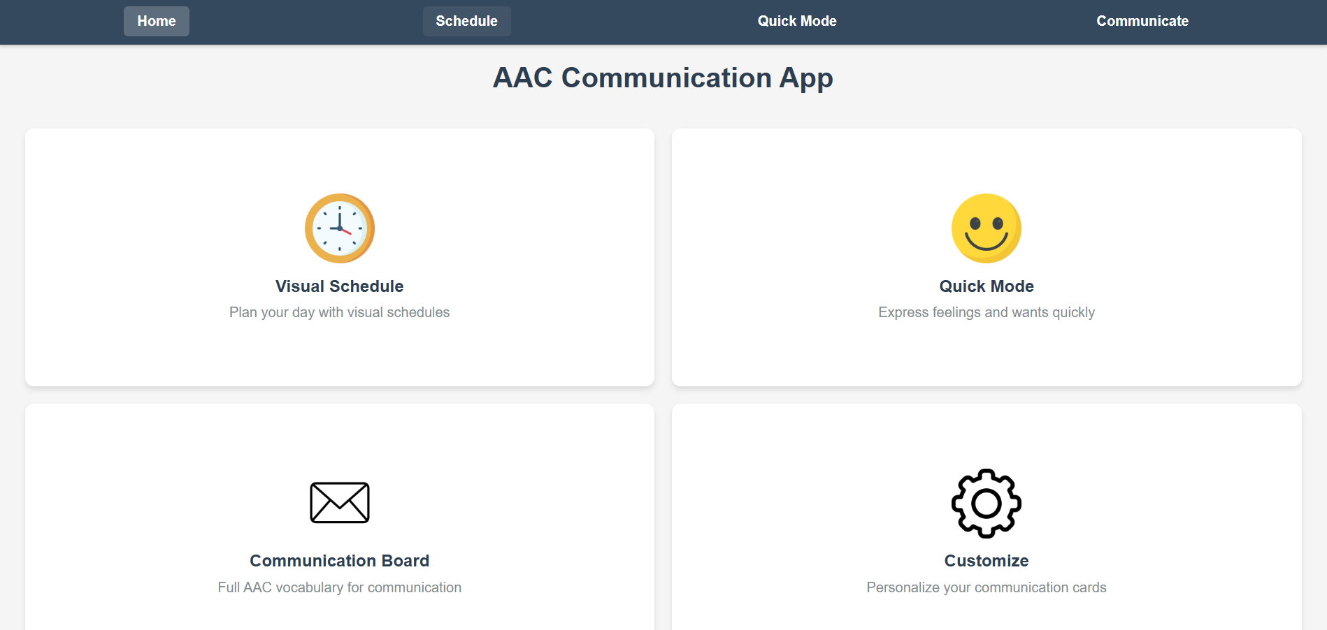

Communication Board
- Purpose: This page is set up similar to other AAC devices like proloquo2go except with a better UI. Users will be leveraging this page to communicate ideas through cards.
- Key Elements:
  - Message Bar:
    - As users select cards, the message bar will display the words that were selected and form a sentence to review progress. In the example of the wireframe the sentence ‘I want to go to the park’ was formed by the user
    - ‘Speak’ button: will play the words as they are displayed in the message area. Claude, you can suggest better names for this button as well if you’d like
    - ‘clear all’ button: will clear the words in the message space.
    - A small red X will appear on the top right hand corner of each word displayed in the message area allowing the user to close those words if they made a mistake or want to remove it leaving the other words in the message section in tact.
    - Users can also reorder words using drag and drop functionality on each individual word in message bar
    - Free form Text: Users can select a keyboard button on the left hand side of the ‘Message’ area to type in their own messages. On a mobile device this should open up the on screen keyboard
    - A backspace button exists on the far left hand side to delete the last thing in the messages area. User should be able to continue to delete each word in the message bar until none are left
    - Next Word Predicter: This functionality works just like how on iphone in the messages app your phone will try to guess your next word. I would like similar functionality here. The app should try to guess the next word based on your previously entered word. This should try to learn the user the more they use the platform to predict what they will do next. I am open to suggestions on the best way to accomplish this.
  - Core Vocabulary: [Layout, organization]
    - Core Vocabulary:
      - This section keeps core vocabulary locked in place unless reorganized by a user.
      - Lock Button: A lock button will appear to keep this section locked by default. The Lock button just features an icon of a lock. If a user taps the lock button 5 times they can open a screen where they can update their core section with their most common phrases.
      - When selecting the lock button a small ribbon should appear on screen that says 4 more times to unlock after the first tab, then 3, then 2 then 1 then unlocked message will appear.
      - I will build this functionality out more in the future but have the lock button in the top right hand corner as a placeholder.
      - Plural: the Plural feature turns the next word selected into a plural if applicable. The Plural feature is the icon with the (s) in the top right of the core words section. For example: pressing the (s) followed by Talk will turn the word into ‘Talks’. This should only apply to words that can be plural
      - UI: this section should be organized in a 3x10 grid as outlined in the wireframe. The cards are color coordinated according to the category they represent. The catagories will be outlined at the end of this document for the MVP of what I will call the dictionary database.

  - Category Navigation:
    - Below the Core Words section is the categories section. 8 Catagories are displayed in this section. The first and last buttons on this section are Previous and Next Buttons. The Previous button should not show unless a user has selected the next button.
    - Selecting the Next button represented in the wireframe as the last button in this area with an arrow pointing to the right will open 8 new catagories. If the next button is selected the previous button should appear
    - The previous button is represented in the wireframe as the first button and is the arrow pointing left. This will bring the user back to the original 8.
    - This area should be responsive and evenly spaced between category cards even when showing/hiding the previous and next buttons
  - Cards Section
    - The bottom section of the screen is where users will select the cards to be displayed on the screen.
    - This section will change based on the last ‘Category’ selected in the section above. In the Wireframe example, the user just selected ‘Food’ which then opened the ‘Food’ Category for this section.
    - When a category is selected the title of the category appears on the left most side as pictured in the wireframe.
    - Next to the name of the category, sub catagories appear. For example if the Food Category was selected, then the appropriate sub categories open. This includes ‘Favorites’, Lunch, Dinner, Snacks, Deserts, Flavors, and Breakfast.
    - When a user selects a sub category Cards appear, so in this example Breakfast was selected so breakfast foods appear like cereal, pop tarts, bacon, pancakes, waffles, etc
    - The previous an next buttons should function the same way as the categories section but only relate to this sub category section. Hitting the next button will reveal the next 12 cards according to the dictionary database.
    - For the paid version the very first tab that should appear is ‘My Favorites’ This section will populate with the cards that the user uses most often.
    - The plural button appears here as well and can be used to turn the subcategory cards to plural words as well.
    - On the bottom right hand side there is a little square with a number. This will highlight to let the user know if the scrolled over to reveal cards what page they are on out of how many. In the wireframe example this user is on page two. Use UX/UI best practices to indicate this to the user.
- User Interactions:
  - Selecting cards: Every time a card is selected the Text to Voice speaks the word on the card and ads the word to the ‘Message Section’
  - The Text to Voice will also speak even if a category or sub category is selected.
- Screenshots/Mockups: Below is a mock up of the UI I created using shapes in Powerpoint. Please use UX/UI Best practices and give suggestions where you think necessary. This is displayed as a tablet in landscape mode. I’m sure I will need to get more created for a mobile device in portrait mode.
  - Each card and Subcatagory tab should be colored according to their category. I do want contrast but please use best practices as it relates to autistic users and colors and UI/UX.
  - Every card should have an icon that represents what the word on the card is and is centered on the card above the text. This shouldn’t be too busy and again follow best practices for UI UX as it relates to users with autism
  - The subcategory tabs should have icons that are left justified on the tabs
  - Please note that I did not include pictures/icons on each of the cards but they should be included.
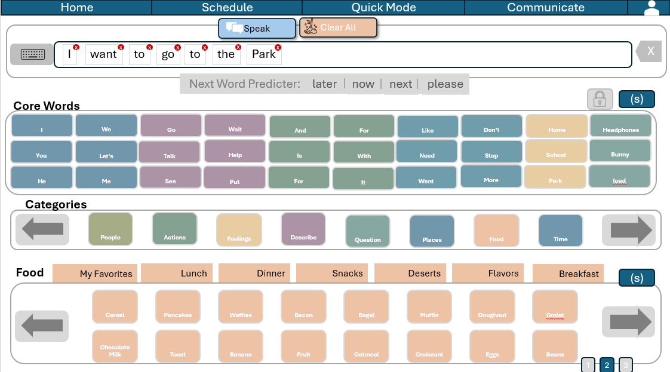
Regarding word prediction and how to store and access historical data for this feature:
A robust word prediction system for your AAC app would need to track user selections over time to improve prediction accuracy. Here's how you could approach it:

Word Prediction Data Storage
- User Interaction History
  - Store sequences of words the user selects in order
  - Track both individual words and common phrases/combinations
  - Include timestamps to give more weight to recent usage
- Data Structure
javascript
Copy
// Example structure for word prediction data
{
"singleWordFrequency": {
"I": 245,
"want": 189,
"go": 156,
// other words with usage counts
},
"wordPairs": {
"I_want": 132,
"want_to": 98,
"to_go": 78,
// other common pairs with counts
},
"wordTriplets": {
"I_want_to": 89,
"want_to_go": 67,
// other common triplets with counts
},
"userSessions": [
{
"date": "2025-04-08T10:30:00",
"sequence": ["I", "want", "to", "go", "to", "the", "park"]
},
// more recent sessions
]
}
- Storage Location
  - Local storage on device for immediate access and offline capability
  - Sync to cloud database (Firebase) for premium users to access across devices
  - Regular pruning of very old data to prevent bloat

Accessing and Using the Data
- Prediction Algorithm
  - After each word selection, analyze the preceding 1-3 words
  - Check for matching patterns in historical data
  - Sort potential next words by frequency and recency
  - Consider context (time of day, current activity if known)
- Implementation Approach
javascript
Copy
function predictNextWords(currentMessage) {
// Get the most recent 1-3 words from the message
const recentWords = getRecentWords(currentMessage, 3);

// Find matches in historical data with decreasing specificity
let predictions = [];

// Try to match the last three words (highest precision)
if (recentWords.length >= 3) {
const tripletKey = `${recentWords[0]}_${recentWords[1]}_${recentWords[2]}`;
predictions = findMatchesAfterSequence(tripletKey, "wordQuads");
}

// If we don't have enough predictions, try matching the last two
if (predictions.length < 3 && recentWords.length >= 2) {
const pairKey = `${recentWords[recentWords.length-2]}_${recentWords[recentWords.length-1]}`;
predictions = [...predictions, ...findMatchesAfterSequence(pairKey, "wordTriplets")];
}

// If still not enough, use just the last word
if (predictions.length < 3 && recentWords.length >= 1) {
const singleKey = recentWords[recentWords.length-1];
predictions = [...predictions, ...findMatchesAfterWord(singleKey)];
}

// Return top 3 unique predictions
return getTopUniquePredictions(predictions, 3);
}
- Updating the Model
  - After each complete message or session, update frequency counters
  - Gradually increase weight of common patterns
  - Implement "forget factor" for older patterns that are no longer used

Performance Considerations
- Optimization
  - Keep the most frequently used prediction data in memory
  - Use efficient data structures (tries or prefix trees) for larger datasets
  - Consider batching updates to the prediction model
- Storage Efficiency
  - Only store meaningful patterns (threshold for minimum frequency)
  - Compress historical data when storing long-term
  - Maintain a fixed-size window of recent interactions (e.g., last 100 messages)
- Privacy and Security
  - Encrypt sensitive prediction data
  - Allow users to clear their prediction history
  - Consider local-only processing for privacy-conscious users
This approach gives you a balance of accuracy and performance, while allowing the system to improve with usage over time. The implementation can start simple and grow more sophisticated as you gather real user data.

Quick Mode

Quick mode is used to gauge a user’s feelings and wants quickly.
- On the left hand side of the screen is the ‘I am Feeling Section’
- A user should select a card for their feelings and TTS should play with an entire sentence saying “I am Feeling [Card Selection]
- On the right hand side isa similar box that says ‘I Want’ and this should include activities, drinks/food, and things that a neurdivergent person would want to request
- In the middle are buttons with common answers and words like (yes, no, Go, Stop, Now, Please, Thank You)
- Multiple pages can be selected by using the arrows similar to functionality outlined in the communication section
- Page numbers show up similarly to the communication page functionality as well.

Wireframe:

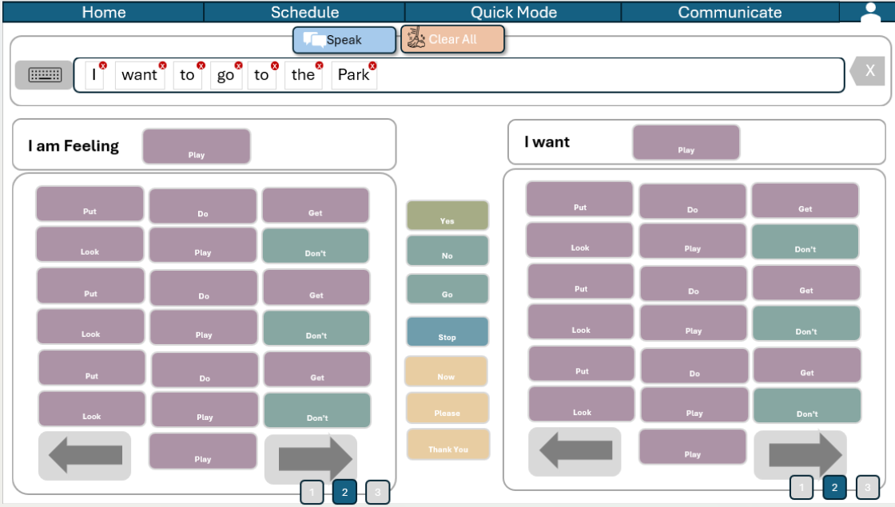

Today’s Schedule

Today’s Schedule is used in order to help neurodivergent people with transitions.
- Today’s Schedule Section: On the left hand side vertically is a space where cards will be placed in order of which they will complete the activities for the day
- This area is built to map out there day. There is an area to save the schedule with morning, afternoon, and evening so that they are stored
- Buttons on the far left side of the screen are used. The first button is to make Today’s Schedule full screen and hide the activity cards so that the focus is centered on Today’s Schedule.
- Users will select cards from the ‘Activity Cards Section
- The Activity Cards Section is where users can select cards to build out their day. Selecting a card will move it to the bottom of the schedule, but users can also drag and drop cards in whatever order they want on today’s schedule from the Activity cards section
- Cards in this section can be dragged and dropped in any order to be rearranged
- A timer exists with timer functionality to set time for how long it takes to get to the next activity. Users should have the ability to set the timer and then the voice will say ‘Name, time for our next activity’.
- The activity card sections have tabs at the top and also page numbers and more functionality similar to the communication board section
- 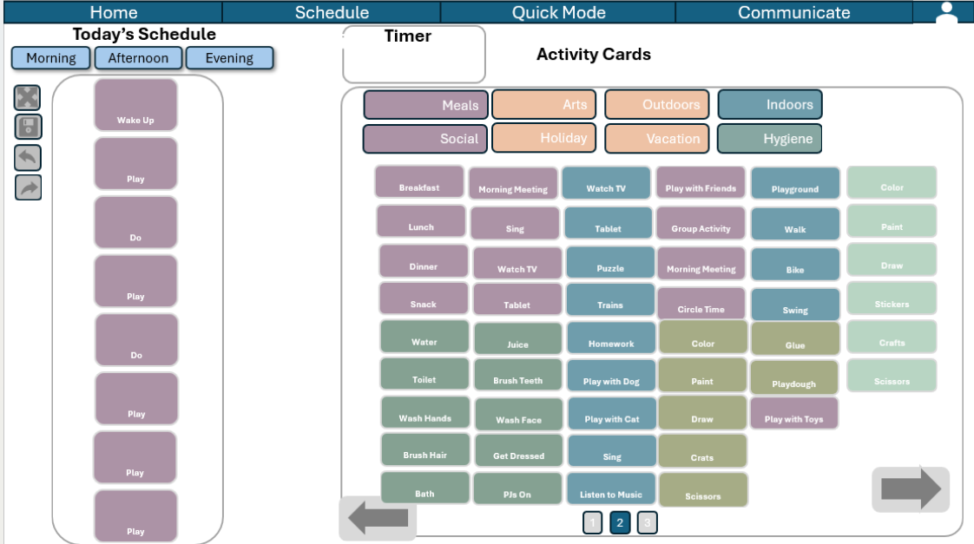

5. Technical Requirements

Authentication
- Methods: Users should be able to login with an email address as their username and password.
  - Also includes: Google Login, Apple Login
- User Profile Data: username (email address) for password resets and usage statistics as outlined.
  - When signing up we should ask for birthday so we have age information

Data Storage
- User Data: What user information is stored
- Vocabulary: How words/phrases are organized
- Custom Cards: Structure for user-created content
- Usage Statistics: What analytics are tracked

Speech Synthesis
- Basic Implementation: Default voice capabilities
- Premium Voices: Advanced options if applicable
- Language Support: How multiple languages are handled

Performance Requirements
- Offline Functionality: What works without internet
- Response Times: Expected performance metrics
- Device Compatibility: Minimum requirements

6. Design Guidelines
- Color Scheme: Primary colors and their meanings
- Typography: Font families and sizes
- Iconography: Style of icons used
- Accessibility: Considerations for users with disabilities

7. Future Roadmap
- Phase 1: [Timeline, key deliverables]
- Phase 2: [Timeline, key deliverables]
- Phase 3: [Timeline, key deliverables]

8. Reference Materials
- Links to any existing designs, prototypes, or code
- References to similar applications or inspiration sources
- Any research materials that inform the app's development
Fill in the sections with your specific requirements, and feel free to modify this template to better suit your project's needs. This document will serve as a comprehensive guide for developing your AAC application.
One reference on color/style
